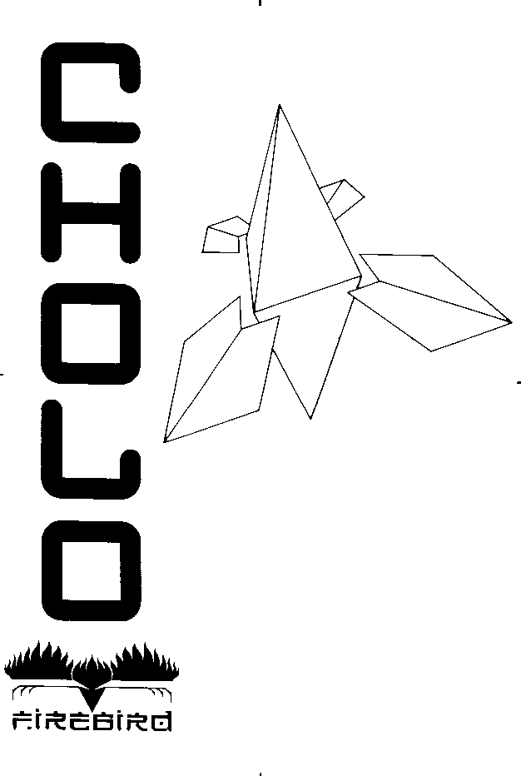

CHOLO for the BBC Micro

BBC LOADING INSTRUCTIONS

Insert your CHOLO game disc into drive 0.
Hold down SHIFT and press BREAK.
After a short delay, the loading screen will be displayed
and the CHOLO music will start to play.
Press any key to move onto the load old game section.
You will now be given the option to load a previously
saved game. Press the Y key if you wish to load an old game
or any other key if you do not wish to do so.
If you pressed Y, remove the CHOLO game disc and insert
your saved games disc. Then type in the name of the file you want
to load and press the RETURN key. When the file has finished
loading, replace the CHOLO game disc and then press any key.

The rest of CHOLO will now load and the game
will start with the MENU SCREEN displayed.
NOTE: keep the CHOLO game disc in the drive at all times, except
when saving, as the program will access this disc during the game.

NOTE: You can only load an old position at the start
of the game. If you want to restart or load in an old
position, press SHIFT and hold down BREAK with the
CHOLO game disc in drive 0. Saved positions have
the prefix C. Do not type in this prefix when entering
an old file name.

Saving your position :
Remove the CHOLO game disc and insert your saved games disc.
Type in a file name up to six characters and press RETURN .
Replace your CHOLO game disc and press any key to continue playing.

INSTRUCTIONS

Objective :

It is important that you read the manual so that you fully understand
the consequences of the holocaust and the enormity of the plight
facing the human race trapped in their nuclear bunker. More
importantly, you will understand the full extent of your responsibility
for their future.

Using the popular bunker game 'RAT', you have access to the only
surface robot under the control of the bunker computer. All other
computers and robots are lost to their own misguided and corrupted
logic circuits; bent on maintaining the seal on the tetrahedral bunker
cap. It is up to you to break this seal.

The robots are not totally lost, by hacking into them, you can
reprogram them to accept your control and to access the surface
computers to gain the information within their files. It is up to you
to use the robots and information that you find wisely, so you can
discover the secret to blowing the bunker cap and freeing the bunker
population.

Getting Started :

Once Cholo has loaded, you will be in menu mode. In the view
screen, you will see a spinning RAT droid, the only robot under
control at this point. Ignore the rest of the menu mode displays for
now and press the select robot key to gain control of the RAT droid.
Your display will look similar to the one shown overleaf.

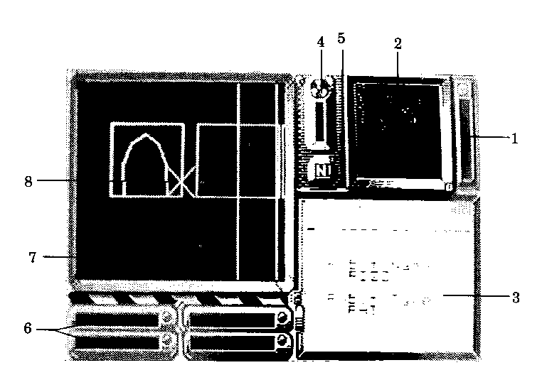

1. Damage 4. Radiation
Shows how much damage a Shows how 'HOT' the area
particular robot has taken. around a robot is. Beware, once
All robots will slowly self radiation reaches a certain
repair. level, dependent on the type of
robot, that robot will take heavy
2. Map / Radar damage until it leaves the area.

Shows an overall view of Cholo 5. Compass
city or your immediate Shows which direction
surroundings if the radar (N,E,S,W) the robot under your
program is installed. Neither control is facing
operate indoors.

3. Message Area 6. Rampaks
All status messages and These rampaks are used to
important clues are displayed hold programs and text files
here, so keep an eye on it. which are vital to solving the
game.

7. View Screen 8. Sights
Shows the camera eye view These will only appear if the
from your robot's surveillance robot under your control is
equipment, or the current robot equipped with a weapon.
in menu mode.

The RAT DROID starts inside the Central Computer building, just
off Bridge Street, facing the entrance. By using the MAIN ROBOT
control keys {given in the key guide} you can move the RAT droid
around the building.

If you steer the RAT into the computer room, shown on the map
below, and collide gently with the CYBER computer inside, the RAT
will establish an interface with CYBER I and will be able to swap
programs with it.

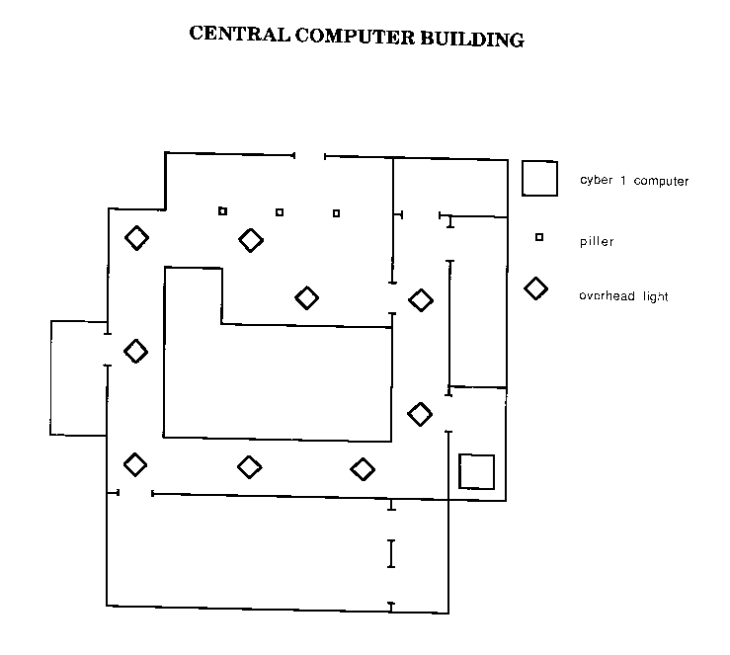

Swapping Programs
Once an interface has been established, you are given the option to:
* READ a program into one of your rampaks
* WRITE a program from a rampak into the computer.
DISCONNECT from the computer.
Use the accelerate / decelerate keys to choose which option you want
and then press the fire key.

READ Gives you a list of all the programs held in the computer's
memory that the interfacing droid is allowed access to.
*This option will not be given if the computer is not holding any
programs.

Use accelerate / decelerate keys to select a program then press the
fire key. Now use the turn left / turn right keys to select which rampak
you want to put the program into then press the fire key.
Note, you can overwrite programs held in a rampak.

WRITE Lets you store programs held in your interfacing robot's
rampaks into a computers memory for safe keeping, and works in
the same way as read. This option will be given if your robot is
not holding any programs.

DISCONNECT Selecting this option and then pressing fire will
log off the computer and return normal control to your robot.

You will find the file PasslTXT (Password-list.text) in the Cyber I.
Read this file into one of the RAT droid's rampaks, disconnect from
the Cyber and then press the goto menu key.

Running Programs
Some programs in a rampak such as RadarPRG work automatically
while others like PasslTXT need to be run.

To run a program held in a rampak, go to menu mode by pressing
the goto menu key and use the next rampak / last rampak keys
to select which program you want to run. Then press the run rampak
key.
The message area will indicate the result of running the program,
if any.

If you run Pass1TXT, you will be given a list of robot entry
passwords! Note these down as you will need these in order to gain
access to the other robots in the game.

Press the select robot key to regain control of the RAT droid and
make your way to the entrance of the Central Computer Building.
Once you leave the building, your view should look like the one below.

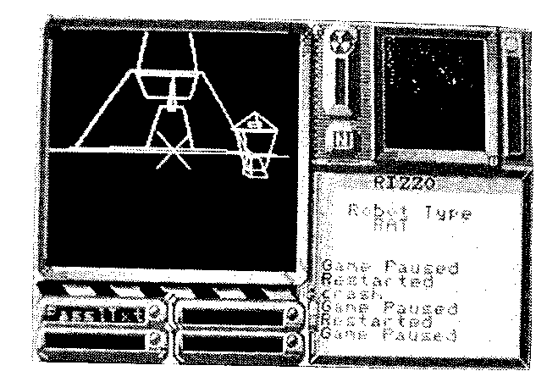

Hacking Other Robots

Now that you are outside, your bird's eye view map of Cholo city will
be operational (unless RadarPRG is being run).

Your position is shown as a flashing dot top and central on the map.

You should also see a small Hacker class robot travelling East down
Bridge Street. Turn right, chase after the Hacker matching its speed
and open fire with the RAT's ion cannon. After several direct hits,
the Hacker will be temporarily paralysed and a confirming
announcement will appear in the message area. Stop firing, otherwise
the Hacker will be too badly damaged to be of any further use. That
is unless you can find a way of repairing it later.

Now guide the RAT up to the Hacker until they are touching, and
an interface between the two will be established.

You will now be given three attempts to enter the Hacker's correct
password. If you get it wrong three times, the robot interface is cut,
though you may try again.

Once you have correctly logged on, you are given the robot's name
and password and the option to swap programs in exactly the same
manner as with the computers.

(It is a good idea to keep important programs in more than one robot
as once a robot 'dies' ,you will loose all the programs which it carried.)

Switching Between Robots

Once you have successfully logged onto the Hacker, Disconnect from
it and press the goto menu key.

You will now find that RIZZO the RAT and IGOR the HACKER
are being alternately displayed in the view screem You now have two
robots under your control!

You can speed up the process of examining the robots under your
control by using the next robot I last robot keys.

The damage and radiation gauges will alter for each different robot
along with its position on the map and rampak contents.
Notice how damaged the Hacker is after the RAT had paralysed it.
A few more shots would have killed it! But as all robots have a self
repair mechanism, the Hacker will be as good as new within a few
minutes.

Use the next robot / last robot keys until the Hacker is shown in
the view screen and press the select robot key. You are now in control
of the Hacker and can guide it around Cholo. Notice that the Hacker
has no sights as it is not equipped with any sort of weapon.

You now know enough of the basics to get used to the controls and
get used to the layout of Cholo city with the aid of your pre-war map,
before attempting to rescue the bunker dwellers.

Teleporters
There are two types of teleporter in Cholo city: one to transport you
from land to land and one to transport you from land to ship.
To use a land to land teleporter, first move a robot on top of one
teleporter pad and stop. You will hear a noise indicating that your
robot is correctly placed on the teleporter pad.

Then take a second robot to the other teleporter and place it on the
teleporter pad, again you will hear the correct position indicator a
few times and then the two robots will swap places.

NOTE: land to land teleporters work in pairs. A given teleporter
is only connected to one other. You will have to find out which
teleporters are connected to each other.

To use a land to ship teleporter, first dock a ship on the side of the
pier closest to the land teleporter. You will be told once you are docked
correctly. Then move the robot you wish to board the ship onto the
land teleporter pad. You will hear the correct position indicator a few

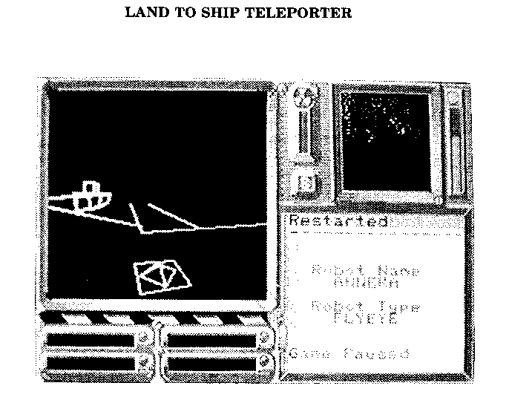
times and then the robot will board the ship. You will be told once
you have boarded correctly.

To leave a ship, first dock the ship, then take control of the robot on
board. The robot will be teleported to the land teleporter.

Helpful Information :

Be very careful around the shoreline, if a robot falls into the sea it
will die and there is no way of getting it back.

Be patient when trying to paralyse the flying eye. It will come down
to earth every now and again.

If the flying eye is up in the air and not moving, move to a new
position some distance from where you are. This is because all robots
are continually working out where to go next, and if you are where
they want to go and they can go no other way they may just sit where
they are.

RadarPRG is invaluable when trying to find robots which have gone
out of view. Sometimes this may be the only way of finding them!

The Guard robots always appear in groups of four patrolling an area.
If you try to take a Guard robot out of its area, it will die.
When you enter a Guard robot patrol area with a new robot, all the
Guard robots in that area will be reset. Therefore, move all the robots
you want into a Guard robot area before you start shooting. Otherwise
the moment you move a new robot into the area, the Guard robots
will be back at full strength and your shooting would have been in
vain.

CHOLO CONTROL KEYS

MAIN ROBOT CONTROLS:
Turn left Z
Turn right X
Accelerate :
Decelerate /
Fire* RETURN
*(only if weapon is fitted)

FLYING EYE CONTROLS:
Up RETURN
Down SPACE
Move left <
Move right >
Pitch up ;
Pitch down @
Yaw left Z
Yaw right X

CAMERA CONTROLS:

Pitch up /
Pitch down :
Yaw left Z
Yaw right X

AEROPLANE CONTROLS:
Throttle up RETURN
Throttle back SPACE
Pitch up /
Pitch down :
Roll left Z
Roll right X

OTHER CONTROLS:
Goto menu ESCAPE
Pause DELETE UnPause COPY

IN MENU MODE:
Next Robot :
Last Robot /
Select Robot RETURN
Save fO You can only save if the last Robot selected was indoors

Next Rampak X
Last Rampak Z
Run Rampak SPACE

CHOLO

WARNING:

Copyright subsists in all Firebird software,
documentation and artwork. All fights reserved. No part
of this software may be copied, transmitted in any form
or by any means. This software is sold on the condition
that it shall not be hired out without the express
permission of the publisher.

No part of this book or accompanying documentation
may be reproduced by any means without the the prior
consent of the copyright holder. The only exceptions are
as provided for by the Copyright (photocopying) act or
for the purpose of review.

Firebird and the Firebird logo we trademarks of British
Telecommunications plc.

CHOLO
For the BBC B, Commodore 64/128, Spectrum 48/128
and Amstrad CPC.

CHOLO was conceived, designed, and programed by :
SOLID IMAGE [S-I] who are JOEY and Glyn
Williams.

Cholo Story by Mark Peirson
Package Design by ASSORTED iMaGes Ltd.
Cover photography by OZ.

If this programme is faulty and fails to load please
return it to the address below and it will be replaced
free of charge. This does not affect your statutory
consumer rights.

Published by:
Firebird Software, first floor, 64/76 New Oxford Street,
London, WCIA 1PS.

