The Micro User Guide To Playing REVS

The Silverstone circuit awaits…

FOR all those drivers who dream of winning a race here's how to beat Max Throttle at his own game without really trying. Let's start by loading in the game.

Revs can be played with the keyboard Shift + fl) or joystick (Shift + 2). Beginners may have found that the game is easier to play with the joystick. This is true to start with, but once you gain experience a keyboard gives better results. In this guide we are going to concentrate mainly on the use of the keyboard.

So settle back into your seat and grasp the steering wheel or, to put it another way, position your hands on the keyboard as shown in Figure I.

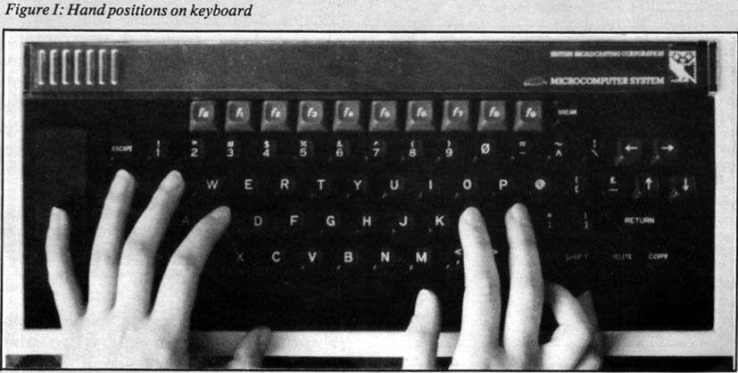

As a clever and attentive reader you will have spotted at once that there is no finger on the brake key, A. (What do you want to slow down for, you're trying to win the race?) The reason for this is that braking is only needed in emergencies. For those joystickoholics who still insist on playing with a joystick, grasp it as you would normally and read on.

The Controls
The Ralt 3 racer is controlled like this: car left is L or stick left, car right is + or stick right. Accelerate is S or stick forward and brake is A or stick backwards. Change up a gear is Q or stick fully forward and push the fire button while change down a gear is Tab or centralise the stick and push the fire button. In either mode the spacebar amplifies the steering and T starts the engine. In joystick mode the fire button acts as the clutch.

When using a joystick you must slide the stick gradually in the desired direction. If you yank the stick over you will skid and spin all over the place. If you are moving fast and brake rapidly by jerking back the stick you will also skid, spin and crash. Try it.

Okay, so you're ready to go. Well not quite, there are still the pit adjustments to make to your car. Start by selecting the practice option (1) then set the rear flaps to 25 and the front to 16. These are the best settings for handling and performance.

You will now find yourself alone on the track at Slverstone. Before yon get all excited and zoom off in a cloud of black evil-smelling smoke it might be a good idea to start the engine. To do this hold down Q, S and T simultaneously. These keys hold in the clutch, depress the accelerator and operate the starter in that order.

When you do this you will find that the car leaps into life, the rev counter starts to move and the engine sound fills your ears. When the rev counter reaches the 5000 mark release the clutch by letting go of the Q key. You should hear the squeal of a wheelspin start. This is not strictly necessary but it gives you a good feeling and can be useful when it comes to starting a real race. Now you are moving!

Keep the car in first gear and drive SLOWLY round the track. Take a good look at the circuit as you go and learn the shape of the curves.

Facts And Figures
THE engine of your Ralt 3 car has only one Power band. This gives the engine its maximum power between 5000 an d 5600 rpm. It is therefore vitally important to keep the rev counter between these values by being in the correct gear for the speed you are doing.

On the Silverstone track there are four corners, a chicane and a hairpin. Have a close look at all of them now because you won't be able to drive and read this at the same time unless you happen to be Zaphod Beeblebrox. You might find it a good idea to have the map (Figure II or from the Rev manual) handy as well.

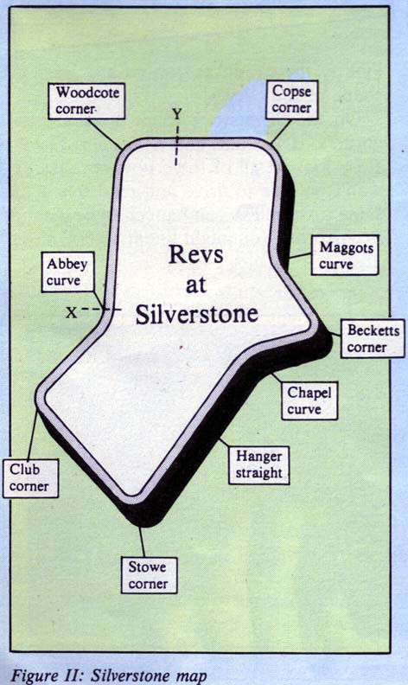

During the qualifying lap, and in practice mode, you start from point X. This gives you plenty of time to build up speed before passing the start line, which is where your lap timings are taken from.

The position of the start (Y) means that you will need to exit the chicane as fast as possible. With practice this can be done in fifth gear with revs around 5300 (smug smile). By the time you have finished what you're reading now you will probably have crashed at least once.

In practice mode when you crash your car it is deposited back on the track at point X. : So when you crash just begin again by starting the engine, holding down Q, S and T...

Keep practising in first gear, getting the feel of how the steering responds to the keys, until you can make it round the whole circuit every time without going off the track. You might get a trifle frustrated, but this really is : the only way to become a good driver, so be patient.

When you can handle the car accurately at a slow speed it is fairly straightforward to build up the speed without too many mishaps. Simply remember that you will have to respond earlier with the controls.

Now start again from point X and move off. As the rev counter reaches 5600 move up a gear (Q). Remember your engine has maximum pulling power in the range 5000-57000 rpm. By the time you approach the chicane you should be in fifth gear.

The Chicane
You will next see the sign warning of the chicane which is followed by two white markers on the left hand side of the track. After the two white markers there is a red one. When you pass this move over to the left hand side of the track while releasing the throttle and changing down to fourth gear.

Cut in to the right. The car will move across on to red and white curbing on the right hand side. As you approach this curb release the steering momentarily, which maintains the steering at a level which will stop you going into a spin.

Although you can cut across the curbing in the chicane and at all the other corners, don't use the curb too much, otherwise your car will tend to take off which does not encourage responsive steering. As you pass the curbing on the right, turn to the left until you pass another red marker on your left, when you should steer right again.

You should steer across more curbing to the right before exiting the chicane on the left side of the track. You probably find this hard to visualise, so look at the plan view (Figure III), which might help to clarify things a little for you.

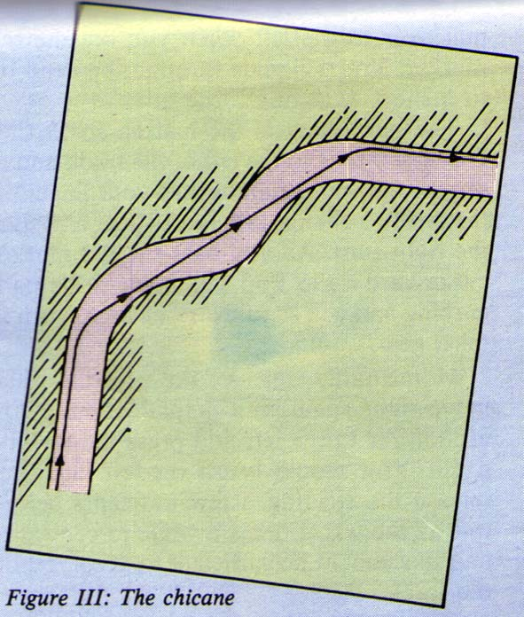

If you don't make it through the chicane the first time you try it, and you probably won't, don't panic. Just count to ten and do it again - in a lower gear if you like.

As in most things, practice makes perfect. The chicane is one of the most difficult things to master on Revs so stick at it until you can 'get through at a good speed without crashing. When you do you will find yourself on a short straight. Halfway down here is a flag on the left side of the track. This is the starting line.

The first corner after the start is a pain, being a fairly sharp right. Approach on the left side of the track and watch for a red marker. As you pass the marker change down a gear, release the accelerator, turn right holding the + key down until you cut across the curbing on the right.

Now release the + key. The car will slide over to the left of the track, and you will need to press the + key again together with the steering amplification (spacebar), to stop the car sliding off the track on to the left hand curbing. When you are through the bend move quickly to the right.

You now enter the hairpin section. This consists of a gentle left turn followed by the hairpin, which is a right then a gentle left again. The first curve is easy to handle in fifth gear with the pedal on the floor. Simply pull over to the left when you see the red marker. You will glide through the bend on to a short straight.

The next thing is the hairpin so SLOW DOWN. Move to the left of the track and at the second white marker take your finger off the throttle, change into fourth gear and start the right turn. As you pass the red marker cut in hard right. You will move to the right curbing and you should now change down to third gear.

Momentarily release the steering then move right again with amplification if you are too far to the left and press the throttle again. You should brush the left curb but release the steering a few moments before this as the wheel takes a while to centralise and this should be sufficient to keep you on the track.

Continue to accelerate as you move into the straight and build up to fifth gear again. The last part of the hairpin section is another gentle left which you can glide through in top gear at top speed.

We now come to the long straight. This is the chance to really put the car through its paces so floor the accelerator and see what it can do. Move gradually over to the left of the track ready for the next curve, which is a right.

As you pass the red marker turn into the corner across the inner curbing and give the steering a touch of amplification. Release the steering slightly before hitting the outer curb allow it to centralise and you should slide out of the curve facing down a short straight. Nearly round the track now, so don't blow it. Move to the left in readiness for the coming right hand turn. Just before the red marker, change down and start the turn holding the + key down to keep the wheel t turning as you enter the bend.

When you hit the inner curb release the steering and accelerate out of the curve. You should come out of the corner reasonably fast, just touching the outer edge of the track. · If you don't make it round this corner the · chances are you're not steering hard enough, so try again - you must hit the inner curb to get safely round this one.

All that's left now is a straight followed by a gentle left before entering the straight where you started. Having come out of the previous corner on the left hand side of the track move over to the right. When you pass the red marker of the next corner simply move in to the left - no need to change down or brake here - and whoosh round the corner at full speed, moving out to the centre of the track before exiting.

Now move back to the left hand side because folks it's back to the chicane situation, so start again at the beginning of the text.

That concludes the step-by-step guide to the Silverstone circuit, but make sure you have memorised the map thoroughly.

Qualifying and Timing
In the novice race it is best to get a qualifying lap time of between 1:30.0 and 1:30.5. If you take longer than 1:30.9 it isn't really worth racing because you start off in the middle of the grid and get squashed and rammed when the pack goes round the First bend.

If you get a lap time faster than 1:30.0 everyone moves up a league and - yes you guessed it-you're back in the middle of the pack.

As a beginner it's pointless trying to enter the professional race to see what it's like, because if you don't get 1:26.0 or faster you will be dumped back into the novice race.

The Race Is On!
WHEN you have mastered the circuit you will want to try your luck in an actual race. It is imperative that you start by entering a novice race.

The qualifying laps are just like driving in practice mode but watch out for other cars. The thing that must be stressed here is that all the other drivers are blind. This is because they are simply trying to get the fastest lap time and will not let a small thing like another car get in their way.

They drive the same path around the curves every time and if you're in the way - well you won't be much longer. After qualifying, with luck you should be fairly well up the grid with not too many cars in front of you.

When you are given the signal from the lights spin the wheels and go!

Carefully weave in and out of the other cars, gradually moving over to the right of the track. The other cars will bunch into groups on the left, with gaps in between. Move into one of these gaps as you near the chicane and hang on the tail of the guy in front.

If you hang back too much you will be rammed from behind and crash.

As the manual states, in novice racing even the worst pile ups are catered for. This means, in effect, that there is always a crane ready to lift your car back on to the track after you've ripped the catch fencing to pieces.

It is worth noting here that in the higher racing levels the crane operators go off for a tea break the moment you set wheels on the grid, so if you crash it's the end of the race for you.
Wings
THE best wing settings are 25 and 16. These settings were found after much time, energy and above all, crashing. When you are used to them and can drive
a mean lap try changing them to 20 and 14.

This tends to be a bit on the spongy side around corners, so freewheel into all curves from the second marker to the red marker, but on the straight sections the car will fly.

In the novice race if you slide off the track but manage to control the spin it is quicker in real terms to crash the car than to mess around trying to get back on the track.

If you come off simply depress one of the gear change keys, hold in the clutch and hit the accelerator before releasing the clutch. The car should leap forward and crash.

After crashing many people frantically hammer the Tab key to change down to neutral for the restart. This is time-wasting and unnecessary. The fastest way to get moving again is to press Tab, S and T together, releasing Tab when the rev counter reaches 5000 and then change down to first gear.

When you move up to the amateur level this technique goes out of the window since crashing terminates your race. So if you're planning to become a professional driver you will need to learn to control a crashing car.

If you come off the track on to a high curb the car will leave the ground completely and you will crash. There is very little you can do to rectify the situation except not to do it in the first place.

If you leave the track on a straight or while overtaking or through being pushed off, just make slow gentle moves to get back on to the track. You will notice very clearly here the difference in grip between the grass and the track. If you panic and turn sharply you will simply spin the car.

If you come off over a low curb change up to fifth gear and release the accelerator. Now find that brake key, A, and repeatedly tap it until the rev counter comes down to 2500. When this happens drive slowly back on to the track. Do not ever hold the brake down you will only succeed in skidding the car beyond control.

If you do spin release the throttle and change into fifth immediately. Tap the brake as above and hope. It was said earlier that sustained braking causes skidding, but when in a spin if all else fails there's nothing to lose, so lean on the brake.

One thing to note is that sometimes the flaps are damaged in a crash, so after a crash or bump move the car from side to side and if the steering seems a bit sloppy press Shift + f0 This will take you into the pits where you can reset the flaps.

But don't worry. As soon as you enter the pit everyone else stops until you are back on the track.
Finer Points
ALTHOUGH you will be busy trying to drive a good race, it is worth looking out for some of the finer points and added touches which give Revs its realism.

For example, when you hit the throttle inertia lifts the front of the car and on braking the nose goes down just as a real car would. It is this which makes Revs the best racing car simulation ever produced for the BBC Micro.

Keep Revvin' 'cos practice makes Perfect!

Written by Revmasters Lee Varga and Clive Packer
Published In The Micro User Vol. 4 Number 1 March 1986
Scanned In By Gary McCallum E-Mail Gary99129@aol.com

