

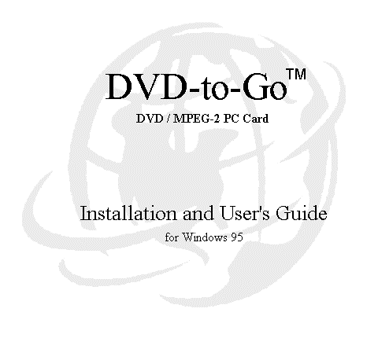

Copyright © 1997-1998 MARGI Systems, Inc. All rights reserved
Revision 1.13

SOFTWARE PRODUCT: DVD-to-Go™ Drivers and associated Applications

SOFTWARE LICENSE AGREEMENT FOR MARGI SYSTEMS PRODUCTS

IMPORTANT—READ CAREFULLY: This MARGI Systems Software License Agreement (“SLA”) is a legal agreement between you (either an individual or a single entity) and MARGI Systems for the MARGI software product identified above, which includes computer software and associated media and printed materials, and may include “online” or electronic documentation (“SOFTWARE PRODUCT’ or “SOFTWARE’). By installing, copying, or otherwise using the SOFTWARE PRODUCT, you agree to be bound by the terms of the SLA.

SOFTWARE PRODUCT LICENSE

The SOFTWARE PRODUCT is protected by copyright laws and international copyright treaties, as well as other intellectual property laws and treaties. The SOFTWARE PRODUCT is licensed, not sold.

GRANT OF LICENSE
- This SLA grants you the rights to install the SOFTWARE PRODUCT in conjunction with the hardware product which it is designed to work with.
- This SLA grants you the right to install the SOFTWARE PRODUCT on multiple computers, provided it is done solely for use with the associated MARGI hardware product.

DESCRIPTION OF OTHER RIGHTS AND LIMITATIONS.
- Limitations on Reverse Engineering, Decompilation, and Disassembly. You may not reverse engineer, decompile, or disassemble the SOFTWARE PRODUCT .
- Separation of Components. The SOFTWARE PRODUCT is licensed as a single product. Its components parts may not be separated for use.
- Rental. You may not rent or lease the SOFTWARE PRODUCT.
- Software Transfer. You may permanently transfer all of your rights under this SLA, provided you retain no copies, you transfer all of the SOFTWARE PRODUCT and the associated hardware (including all component parts, the media and printed materials, any upgrades, this SLA), and the recipient agrees to the terms of the SLA.
- Termination. Without Prejudice to any other rights MARGI may terminate this SLA if you fail to comply with the terms and conditions of this SLA. In such event, you must destroy all copies of the SOFTWARE PRODUCT and all of its components parts.

COPYRIGHT
- All title and copyright in and to the SOFTWARE PRODUCT (including but not limited to any images, photographs, animations, video, audio, music, text, and “applets,” incorporated into the SOFTWARE PRODUCT), the accompanying printed materials, and any copies of the SOFTWARE PRODUCT, are owned by MARGI or its suppliers. The SOFTWARE PRODUCT is protected by copyright laws and international treaty provisions. Therefore, you must treat the SOFTWARE PRODUCT like any other copyrighted material. You may not copy the printed materials accompanying the SOFTWARE.

Limited Warranty

LIMITED WARRANTY. MARGI warrants that (a) the SOFTWARE PRODUCT will perform substantially in accordance with the accompanying written materials for a period of ninety (90) days from the date of receipt, and (b) any hardware accompanying the SOFTWARE PRODUCT will be free from defects in materials and workmanship under normal use and service for a period of six (6) months from the date of receipt.

CUSTOMER REMEDIES. MARGI’s and its suppliers’ entire liability and your exclusive remedy shall be, at MARGI’s option, either (a) return of the price paid, or (b) repair or replacement of the SOFTWARE PRODUCT or hardware that does not meet MARGI’s Limited Warranty and which is returned to MARGI with a copy of your receipt. This Limited Warranty is void if failure of the SOFTWARE PRODUCT or hardware has resulted from accident, abuse, or misapplication. Any replacement SOFTWARE PRODUCT or hardware will be warranted for the remainder of the original warranty period or thirty (30) days, whichever is longer.

NO OTHER WARRANTIES. TO THE MAXIMUM EXTENT PERMITTED BY APPLICABLE LAW, MARGI AND ITS SUPPLIERS DISCLAIM ALL OTHER WARRANTIES, EITHER EXPRESS OR IMPLIED, INCLUDING, BUT NOT LIMITED TO, IMPLIED WARRANTIES OF MERCHANTABILITY AND FITNESS FOR A PARTICULAR PURPOSE, WITH REGARD TO THE SOFTWARE PRODUCT, AND ANY ACCOMPANYING HARDWARE.

NO LIABILITY FOR CONSEQUENTIAL DAMAGES. TO THE MAXIMUM EXTENT PERMITTED BY APPLICABLE LAW, IN NO EVENT SHALL MARGI OR ITS SUPPLIERS BE LIABLE FOR ANY SPECIAL, INCIDENTAL, INDIRECT, OR CONSEQUENTIAL DAMAGES WHATSOEVER (INCLUDING, WITHOUT LIMITATION, DAMAGES FOR LOSS OF BUSINESS PROFITS, BUSINESS INTERRUPTION, LOSS OF BUSINESS INFORMATION, OR ANY OTHER PECUNIARY LOSS) ARISING OUT OF THE USE OF OR INABILITY TO USE THE SOFTWARE PRODUCT OR ACCOMPANYING HARDWARE, EVEN IF MARGI HAS BEEN ADVISED OF THE POSSIBILITY OF SUCH DAMAGES.

Safety and Regulatory Information

CAUTION: To avoid shock hazard, do not connect or disconnect any cables or perform installation, maintenance, or reconfiguration of this product during an electrical storm.

Copyright & Trademark Notice

DVD-to-Go™ is a trademark of MARGI Systems, Inc.

DOLBY STATEMENT

DVD-to-Go™ is manufactured under license from Dolby Laboratories. Dolby and the double-D symbol are trademarks of Dolby Laboratories. Confidential Unpublished Works. © 1992-1997 Dolby Laboratories, Inc. All rights reserved.

MACROVISION STATEMENT
This product incorporates copyright protection technology that is protected by method claims of certain U.S. patents and other intellectual property rights owned by Macrovision Corporation and other rights owners. Use of this copyright protection technology must be authorized by Macrovision Corporation, and is intended for home and other limited viewing uses only unless otherwise authorized by Macrovision Corporation. Reverse engineering or disassembly is prohibited. MARGI Systems, Inc. DVD-to-Go™ card (525/60/NTSC and 625/50/PAL) is compliant with section 1A and 2 of the Macrovision 7.01 specification.

MARGI Systems, Inc. is a licensee of CSS Interim License Agreement under the following membership categories:
- DVD Decoder card manufacturer (hardware and software).
- Descramble chip manufacturer.
- Authentication chip manufacturer for DVD Decoder card.

Windows 95 is trademark of Microsoft Corporation, all rights reserved. All other trademarks belong to their respective owners.

System Requirements

Notebook Computer with Zoomed Video (ZV) Enabled PCMCIA Socket

Processor: Pentium (586) 100 MHz or higher
Memory: 16MB RAM or more
Operating System: Windows 95
Hard Drive Space: At least 10MB
Display Type: SVGA or higher
Other Requirements: PCMCIA Type ΙΙ Socket w/ Card and Socket Services
Sound Card and Speakers for audio playback

Table of Contents

Introduction. 1
Installing Software 2-4
Launching MARGI DVD Player .. .5
Understanding the Video / Audio Cable 6
Understanding the DVD Player 7-13
Understanding the Playback Buttons 14-15
Creating a Shortcut or Icon for the DVD Player . .16
Uninstalling the DVD-to-Go™ Drivers . 16
Understanding Your Region Code . 17-19
Appendix A: Product Specification . 20
Appendix B: Troubleshooting . 21
Appendix C: Technical Support Contact Information 22
Glossary of Terms . 23
Technical Support Form 24

List of Figures

Figure 1 - PC Card displays both empty slots 2
Figure 2 - New Hardware Found with OSR2 - PC Card. 2
Figure 3 - PC Card displays configured card 3
Figure 4 - Locate the drive location for DVD Playback 5
Figure 5 - Video/Audio Cable … 6
Figure 6 - DVD Player / Navigator … 7
Figure 7 - DVD Display . 14
Figure 8 - Playback Buttons Display . 14
Figure 9 - Map of World with Different Regions . 17
Figure 10 - Table of Countries along with their Region Codes 17-19

Introduction

The DVD-to-Go™ card is a Type ΙΙ PCMCIA card designed to decode high quality DVD encoded media e.g. Movies and playback MPEG-2 and Dolby AC3 audio for video display and audio output. Video is displayed in full-color at full screen and with full motion (30 frames per second). The CD-quality stereo audio is fully synchronized with the video for seamless viewing.

The DVD-to-Go™ card offers end-users the ability to provide broadcast quality video Sales and Business Presentations and a true multimedia entertainment experience. DVD-to-Go™ offers stunning color displays and richer audio with the use of Dolby® Digital Surround Sound. The card is designed for use with any standard ZV-notebook, DVD-to-Go™ is a PC-Card add-in module and is Plug & Play for easy installation and use.

MARGI Systems, Inc. Introduction - 1

Installing Software

The instructions are for installing the DVD-to-Go™ MCI drivers on:
- Windows 95 [4.00.950 B] – OSR2 (Plug-and-Play Support).
- VPM 1.10 or VPM 1.05.
- PCMCIA 5.0 Card and Socket Services.
- Zoomed Video (ZV) Support.

Run PC Card Property from the Control Panel to detect new card (see Figure 1).

Figure 1 - PC Card displays both empty slots.
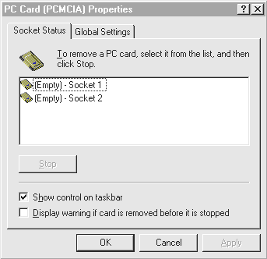

Simply insert the DVD-to-Go™ Card into the ZV-Enabled slot.

Figure 2 - New Hardware Found with OSR2 - PC Card
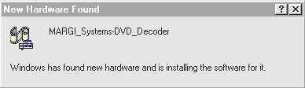

IMPORTANT: Windows 95 will prompt for the location of the file ‘MARGIPNP.VXD’ since it could not be found. At this point, simply type D:\ (or the location of the installation CD-ROM disc in which this file is located), and click OK. The drivers will then be automatically installed.

After the installation is complete, there will be 2 loud beeps once the card is recognized. (see Figure 3)

MARGI Systems, Inc. Installing Software - 2
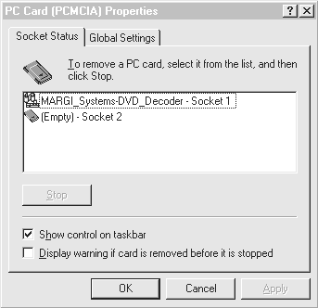
Figure 3 - PC Card displays configured card

While the DVD-to-Go™ Driver CD-ROM is still in the CD-ROM drive. Type D:\SETUP.EXE (where D:\ represents the location of the installation driver).

Follow the instructions on the screen. (It is recommended to use the Default setup during the installation). During the installation procedure, you will be prompted to choose your regional code. For help in determining your regional code, please refer to the “Understanding Your Regional Code” section.

It is important to select the desired region understanding that once the selection has been made, you CAN ONLY play the DVD titles from that region. Please read through the IMPORTANT note below for more information about your DVD title.
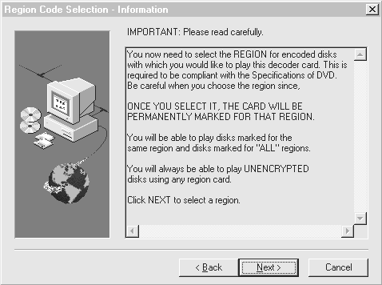

MARGI Systems, Inc. Installing Software - 3
Choose I don’t know! Need some suggestions if you are not familiar with which region for the encoded disks. Please refer to the Understanding Your Region Code on how to determine the region code for your DVD Title.
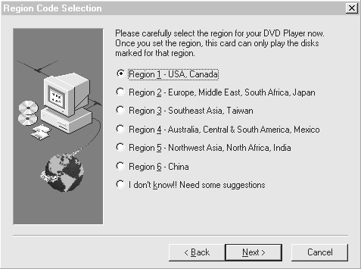
By clicking Next > button after choosing a region, dialog box below will give you a listing of all the countries that belong to that particular region. IF YOU ARE NOT SURE OF THE COUNTRY OR REGION YOU HAVE CHOSEN, CLICK THE < BACK BUTTON TO GO BACK TO THE REGION SELECTION DIALOG BOX.
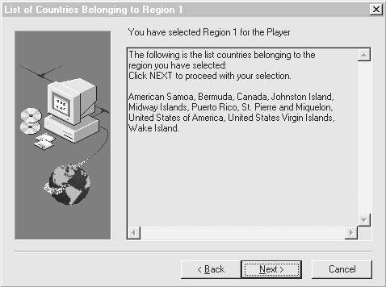

MARGI Systems, Inc. Installing Software - 4

Launching the MARGI DVD Player

- Set your desktop’s display resolution at least 800 x 600 pixels and to 256 colors. If the display controller and display panel support higher display resolution and color, you can set the system to a higher displays (1024 x 768 and High Color – 16bit).

- Click the Start button, point to Programs, MARGI, and then click MargiDVD. (Refer to the section “Creating a Shortcut or Icon for the DVD Player” for instructions on how to create a shortcut).

- If this is the first time you are launching MargiDVD Player, the error message box (DVD-ROM Missing – see figure 4 below) will appear asking for the location of the DVD drive. Select the correct drive letter of your DVD-ROM drive (ex. If the DVD drive is setup for letter D, simply choose “Select” button, and browse to the appropriate drive letter.)

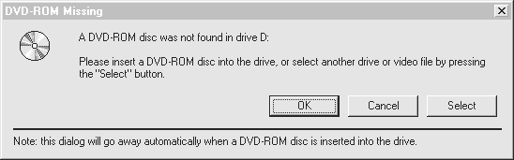
Figure 4 - Locate the drive location where the DVD drive is located

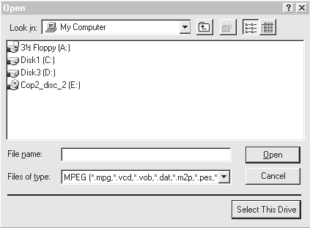
NOTE: This special setting is required to configure only one time for assigning the drive letter.

- Select a drive by double-click on the drive letter [Example: Cop2_disc_2 (E:) is a DVD drive] and click on the Select This Drive button.
MARGI Systems, Inc. Launching the MARGI DVD Player - 5

Understanding the Video/Audio Cable

The DVD-to-Go™ card is equipped with a Video (Video Source & S-video Outputs) and Audio (Right & Left Outputs) cable (see Figure 5). If you want to output DVD on your TV set, you can connect the TV to the Video Output using either the S-Video or Composite cable.

Figure 5 - Video/Audio Cable
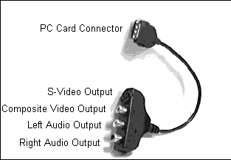

MARGI Systems, Inc. Understanding the Audio/Video Cable - 6

Understanding the DVD Player Panel

NOTE: The LOCK and X marks on the buttons are described as follow:
The LOCK mark appears only when certain scene is required to be played through without any
interfering. The mark will disappear once the scene is done playing.
This X mark shows this particular option is NOT present or available from the DVD disc.

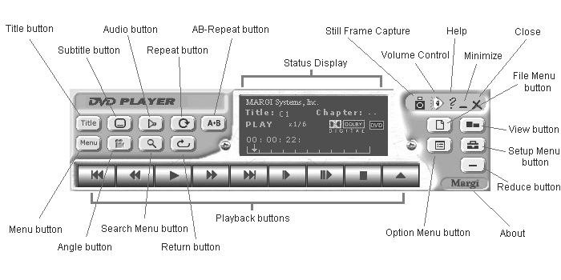
Figure 6 – DVD Player Panel / Navigator

If a DVD video disc contains a title menu, a specific title can be located by clicking the Title button.

Use the Menu button to display the menu screen included on DVD video disc. It allows the user to select particular sequences or functions available.

During the playback, you can choose different subtitle language from those included on the DVD video disc. It allows to have a selection of up to 32 subtitles.

If a particular scene was recorded from multiple angles, you can switch the camera angle up to 9 different camera angles (multiple angles) of the scene you are currently watching.

During the playback, you can choose a playback audio setting such as language, recording system and audio channel).
MARGI Systems, Inc. Understanding the DVD Player Panel - 7
Use the Search Menu button to locate a specific chapter or track.
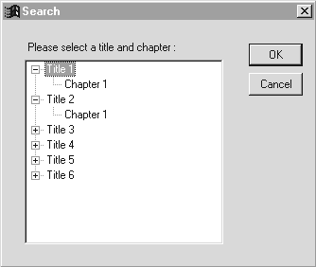

Use the Repeat button to play back a specific title, chapter, track, or segment repeatedly.

Use the Return button to return back to the Menu after the settings have been made.

Use the A-B Repeat button to define and continuously play a segment. The first click sets the start, the second sets the end and the third starts the continuous play.

Use the Option button to select color schemes available for the Control Panel.
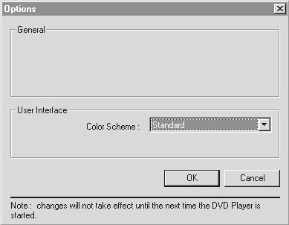

Use the File Menu button to open your favorite file from DVD video disc, CD-ROM, or the hard disk.

The View button displays the playback video either in
- Native Size
- Full Screen
- Custom Size

MARGI Systems, Inc. Understanding the DVD Player Panel - 8

Use the Less/Reduce button to resize the DVD Player panel. By pressing the More button will switch the panel back to its original size.

Use the Setup button to open multiple function windows.

NOTE: By pressing the SETUP button prior inserting the DVD disc, you can set up the Disc Menu, Audio, Sub Title, Parental Control and Display properties. Secondly, pressing the SETUP button while the DVD disc is currently running, the MPEG Preperties will display information about the video and audio formats. (Scroll down to the MPEG Properties for further instructions).

- Disc Menu : To select the language used for menu display.
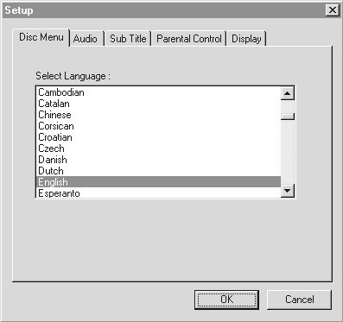

- Audio : To select the language used for audio playback.
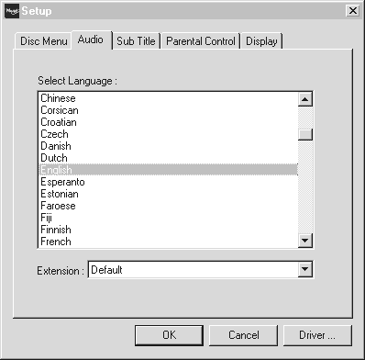

MARGI Systems, Inc. Understanding the DVD Player Panel - 9

- Sub Title : To select the language used for Sub Title display. The Sub Title can be disabled at startup.
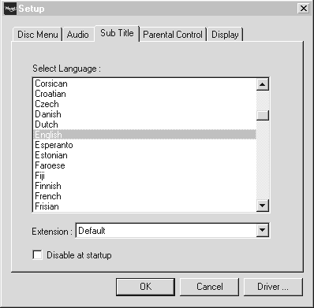

- Parental Control : To be able to exclude certain scenes from a movie. Please follow the chart below for the parental level
Level 8 – Restricted
Level 7 –
Level 6 –
Level 5 –
Level 4 –
Level 3 –
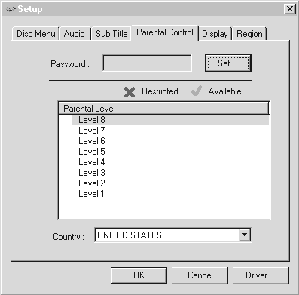
Level 2 –
Level 1 – Child Safe

MARGI Systems, Inc. Understanding the DVD Player Panel - 10

- Display : To select the display mode suitable for viewing.
Letterbox – (16:9 video for 4:3 display)
Widescreen – (16:9 video for 16:9 display)
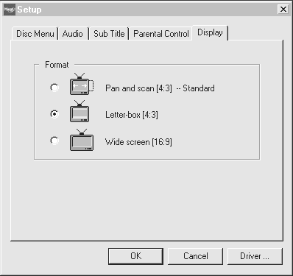
Pan & Scan – (16:9 video for 4:3 display)

- Region : The current setup region will be displayed as the default.
After changing the region code for the 4th time, the DVD-to-GoTM PC Card is permanently fixed. You may not be able to change to another region again. This is due to CSS Interim License Agreement under the following membership categories:
- DVD decoder card manufacturer (hardware or software).
- Descramble chip manufacturer.
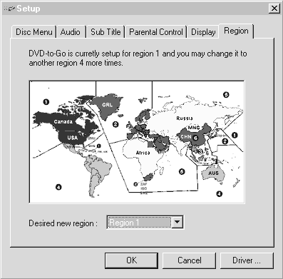
- Authentication chip manufacturer for DVD decoder card.

MARGI Systems, Inc. Understanding the DVD Player Panel - 11
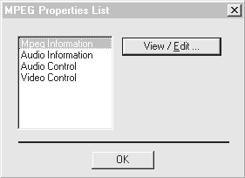
Figure 7 - MPEG Properties

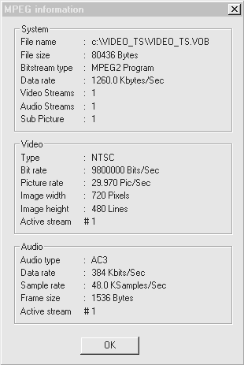
- MPEG Information : To select the language used for audio playback.

MARGI Systems, Inc. Understanding the DVD Player Panel - 12

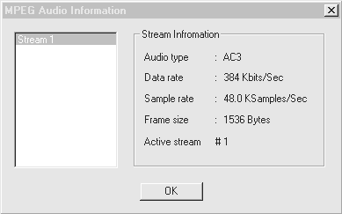
- Audio Information : To select the language used for audio playback.

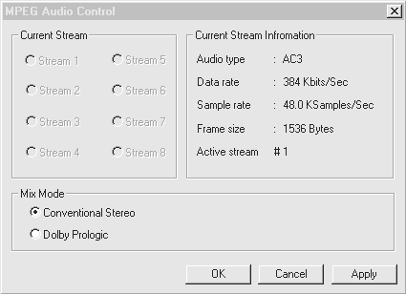
- Audio Control : To select the language used for audio playback.

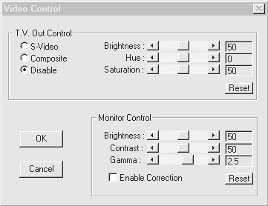
- Video Control : To select the language used for audio playback.
MARGI Systems, Inc. Understanding the DVD Player Panel - 13
Figure 7: DVD Display
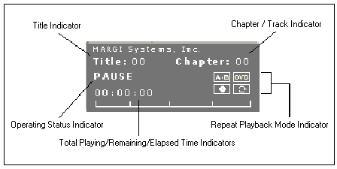

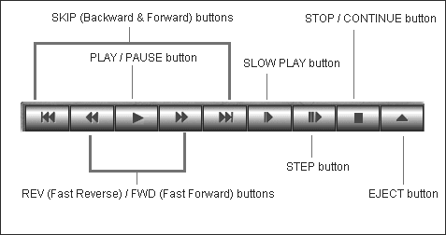
Figure 8: Playback Buttons Display

PLAY/ PAUSE Button: The onscreen menu usually appears after launching the DVD Player.

STOP/ CONTINUE Button: After pressing the STOP button, you can continue play the current chapter by clicking on the button again.

EJECT Button: To open the disc tray.

MARGI Systems, Inc. Playback Buttons - 14

STEP BACKWARD Button: By pressing the STEP BACKWARD button once, the DVD player starts playback from the beginning of the current chapter or track. By pressing the STEP BACKWARD button twice, the DVD player starts playback from the beginning of the preceding chapter or track.

STEP FORWARD Button: To locate subsequent chapters or tracks.

____  ____

REWIND Button. (see below for more information)

FAST FORWARD Button. (see below for more information)

Press FAST FORWARD / REWIND button to playback at 2x the normal speed. Press FAST FORWARD / REWIND button again to change the speed to 8x the normal speed. Press the PLAY button to resume back to the normal playback speed.

____  ____

SLOW PLAY Button: By pressing the SLOW PLAY Button once, the playback speed becomes half (1/2) the normal speed. Each time pressing the button, the playback speed changes as (1/2) – (1/6) – (1/8). Press PLAY button to resume back to the normal playback speed.

____  ____

SINGLE PLAY Button: By pressing the SINGLE STEP Button
each time, the picture moves forward one frame at a time.

MARGI Systems, Inc. Playback Buttons - 15

Creating a Shortcut or Icon for DVD Player

Windows 95:

- Using Windows Explorer, find the DVDPlay.EXE file in your C:\MargiDVD directory (or the name of the drive and directory that contains the MARGI’s DVD files).

- Click once on the file, then click the right button once. Choose Create Shortcut from the menu that appears.

- Drag the new Shortcut to DVDPlay.EXE file onto your desktop. You can now double click on that icon to run the MARGI’s DVD application.

Uninstalling the DVD-to-Go™ Drivers

The instructions are for the removal of the DVD-to-Go™ drivers.

…Your DVD Player Application

- Start Windows normally.
- Assure that your DVD-to-Go™ PC Card is inserted.
- Click Start : Settings : Control Panel.
- While in Control Panel, double click on the Add/Remove Programs icon.
- From the list of software titles, choose MARGI Systems DVD-to-Go, then click on Add/Remove…
- Follow the onscreen instructions for removal of the drivers.

…Your Device Manager

- Assure that your DVD-to-Go™ PC Card is still inserted.
- Click Start : Settings : Control Panel.
- Click the Device Manager tab and confirm that you are viewing the devices by type.
- Look for and Remove the MARGI_Systems-DVD_Decoder setting inside Sound, video and game controllers.
- Click OK and close Control Panel.

…Your System
- Click Start : Programs : Windows Explorer. A window called Exploring C:\ will come up.
- Click View : Options : Show All Files : OK.
- Click Tools : Find : Files or Folders.
- Look for and delete files that Windows Explorer locates under following names:

MARGIPNP.VXD (located in C:\Windows\System)
Margi Systems, Inc.DVDTOGO.INF (located in C:\Windows\Inf\Other)

- You may pull your PC Card out of its slot.
MARGI Systems, Inc. Optional - 16

Optional: Understanding Your Regional Code

Regional codes are standard for the DVD format.

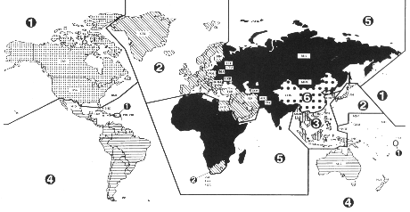
Figure 9: Map of world with different regions

There are six (6) major regions:

Region 1: USA, Canada.
Region 2: Europe, Middle East, South Africa, Japan.
Region 3: Southeast Asia, Taiwan.
Region 4: Australia, New Zealand, Central & South America, Mexico.
Region 5: Northwest Asia, North Africa, India.
Region 6: China.

Figure 10: Table of Countries along with their Regional Codes
Country | Code | Country | Code
Afghanistan | 5 | Bahrain | 2
Albania | 2 | Bangladesh | 5
Algeria | 5 | Barbados | 4
American Samoa | 1 | Belarus | 5
Andorra | 2 | Belgium | 2
Angola | 5 | Belize | 4
Anguilla | 4 | Benin | 5
Antigua and Barbuda | 4 | Bermuda | 1
Argentina | 4 | Bhutan | 5
Armenia | 5 | Bolivia | 4
Aruba | 4 | Bosnia and Herzegovina | 2
Australia | 4 | Botswana | 5
Austria | 2 | Brazil | 4
Azerbaijan | 5 | British Indian Territory | 5
Bahamas | 4 | British Virgin Islands | 4

MARGI Systems, Inc. Understanding Your Regional Code - 17
Figure 10: Table of Countries along with their Regional Codes (Continue)
Country | Code | Country | Code
Brunei Darussalam | 3 | Greece | 2
Bulgaria | 2 | Greenland | 2
Burkina Faso | 5 | Grenada | 4
Burundi | 5 | Guadeloupe | 4
Cambodia | 3 | Guam | 4
Cameroon | 5 | Guatemala | 4
Canada | 1 | Guinea | 5
Cape Verde | 5 | Guinea-Bissau | 5
Cayman Islands | 4 | Guyana | 4
Central Africa | 5 | Haiti | 4
Chad | 5 | Honduras | 4
Channel Islands | 2 | Hong Kong | 3
Chile | 4 | Hungary | 2
Christmas Island | 4 | Iceland | 2
Cocos Islands | 4 | India | 5
Colombia | 4 | Indonesia | 3
Commonwealth of Dominica | 4 | Iran | 2
Comoros | 5 | Iraq | 2
Congo | 5 | Ireland | 2
Cook Islands | 4 | Isle of Man | 2
Costa Rica | 4 | Israel | 2
Cote d’Ivoire | 4 | Italy | 2
Croatia | 2 | Jamaica | 4
Cuba | 4 | Jammu and Kashmir | 5
Cyprus | 2 | Japan | 2
Czech | 2 | Johnston Island | 1
Denmark | 2 | Jordan | 2
Djibouti | 5 | Kasakhastan | 5
Dominican Republic | 4 | Kenya | 5
East Timor | 3 | Kiribati | 4
Ecuador | 4 | Korea | 3
Egypt | 2 | Kuwait | 2
El Salvador | 4 | Kyrgyz Republic | 5
Equatorial Guinea | 5 | Laos | 3
Eritrea | 5 | Latvia | 5
Estonia | 5 | Lebanon | 2
Ethiopia | 5 | Lesotho | 2
Faeroe Islands | 2 | Liberia | 5
Falkland Islands | 4 | Libya | 5
Federal Republic of Yugoslavia | 2 | Liechtenstein | 2
Fiji | 4 | Lithuania | 5
Finland | 2 | Luzembourg | 2
France | 2 | Macau | 3
French Guiana | 4 | Macedonia | 2
French Polynesia | 4 | Madagascar | 5
Gabon | 5 | Malawi | 5
Gambia | 5 | Malaysia | 3
Georgia | 5 | Maldives | 5
Germany | 2 | Mali | 5
Ghana | 5 | Malta | 2
Gilbraltar | 2 | Marshall Islands | 4

MARGI Systems, Inc. Understanding Your Regional Code - 18
Figure 10: Table of Countries along with their Regional Codes (Continue)
Country | Code | Country | Code
Martinique | 4 | Sao Tome and Principe | 5
Mauritius | 5 | Saudi Arabia | 2
Mayotte | 5 | Senegal | 5
Mexico | 4 | Seychelles | 5
Micronesia | 4 | Sierra Leone | 5
Midway Islands | 1 | Singapore | 3
Moldova | 5 | Slovakia | 2
Monaco | 2 | Slovania | 2
Mongolia | 5 | Solomon Islands | 4
Montserrat | 4 | Somalia | 5
Morocco | 5 | South Africa | 2
Mozambique | 5 | Spain | 2
Myanmar | 3 | Sri Lanka | 5
Namibia | 3 | St. Pierre and Miquelon | 1
Nauru | 4 | Sudan | 5
Nepal | 5 | Suriname | 4
Netherlands | 2 | Svalbard & Jan Mayen Island | 2
Netherlands Antilles | 4 | Swaziland | 2
New Caledonia | 4 | Sweden | 2
New Zealand | 4 | Switzeland | 2
Nicaragua | 4 | Syrian Arab Emirates | 2
Niger | 5 | Tadzhikistan | 5
Nigeria | 5 | Taiwan | 3
Niue | 4 | Tanzania | 5
Norfolk Island | 4 | Thailand | 3
North Korea | 5 | Togo | 5
Northern Mariana Islands | 4 | Tokelau | 4
Norway | 2 | Tonga | 4
Oman | 2 | Trinidad and Tobago | 4
Pakistan | 5 | Tunisia | 5
Palau | 4 | Turkmenistan | 5
Panama | 4 | Turks and Caiso Islands | 4
Papua New Guinea | 4 | Tuvalu | 4
Paraguay | 4 | Uganda | 5
People’s Republic of China | 6 | Ukraine | 5
Peru | 4 | United Kingdom | 2
Philippines | 3 | United States of America | 1
Pitcairn | 4 | United States Virgin Islands | 1
Poland | 2 | Uruguay | 4
Portugal | 2 | Uzbekistan | 5
Puerto Rico | 1 | Vanuatu | 4
Qatar | 2 | Vatican City State | 2
Reunion | 5 | Venezuela | 4
Romania | 2 | Vietnam | 3
Russia | 5 | Wake Island | 1
Rwanda | 5 | Wallis and Futuna Islands | 4
Saint Christopher and Nevis | 4 | Western Sahara | 5
Saint Lucia | 4 | Yemen | 2
Saint Vincent & the Grenadines | 4 | Zaire | 5
Samoa | 4 | Zambia | 5
San Marino | 2 | Zimbabwe | 5

MARGI Systems, Inc. Understanding Your Regional Code - 19

appendix A: Product Specifications

Unique Product Characteristics
- High Performance video resolution at 720x480 (16 million colors)
- Richer than CD quality sound (Frequency response: 10Hz - 20kHz; signal-to-noise ratio: 96dB)
- Digital Surround Sound with 5.1 channels
- Sharp slow motion and freeze-frame video
- Multiple Camera Angle option
- Supports up to 8 language tracks, 32 subtitle languages
- Low Power Dissipation: 1.5 Watts
- Low CPU Usage

Hardware Specifications
- Type II PCMCIA card compatible with the Zoomed Video (ZV) Standard
- MPEG-2 Video AC3 Audio
- MPEG-1 Video / Audio
- Fully Compatible CSS Decryption & Region Code
- Macrovision 7.0 with NTSC or PAL output (optional)
- Stereo Audio Output
- SPDIF 6 Channel Output (Optical, optional)
- Analog Stereo (2 Channel) I2S for ZV Interface
- Karaoke Mode
- 16 bit YUV Video Interface providing TrueColor Quality
- 16 bit digital Audio Interface providing CD Quality Sound

Software Specifications
- Hot Plug & Play Interface with Win 95 & Win NT 5.0
- MCI for Win 95
- Active Movie 1.0 Filter Win 95
- WDM Driver for Win 95 and Win NT 5.0
- Win NT 5.0
- DVD Navigator
- Video CD 2.0 Support
- Multiple ZV Client Support

Normal Operating Specifications
- Typical Operation Power dissipation: 1.5 Watts
- Operating Voltage: 5 Volts
- Operating Temperature Range: 5°C∼30°C
- Operating Relative Humidity Range: 30%∼80%

MARGI Systems, Inc. Appendix A: Product Specifications - 20

appendix B: Troubleshooting

Symptom: The video displayed on the screen is mixed with green and magenta colors.

Possible cause: The DVD-to-Go™ Card is NOT plugged into a Zoomed Video (ZV) Enabled slot.

Corrective Action: Ensure that the card is inserted into a Zoomed Video Enabled slot (usually the bottom slot). Please refer to the notebook manual for more information.

Symptom: The playback video is not smooth.

Possible causes: 1) The DMA transfer not enabled.
2) The Cache memory is not being set to max size.

Corrective Actions: 1) Enable the DMA transfer on DVD-ROM by opening SYSTEM under CONTROL PANEL, click the Device Manager tab and double-click the CD-ROM icon. Select the DVD-ROM and select Properties. Under the SETTINGS tab, check the DMA option. Note: The system will restart after the setting is made. Insure that all applications have been closed.

2) Enable the Cache at full setting by opening SYSTEM under CONTROL PANEL, click the PERFORMANCE tab and choose FILE SYSTEM under Advanced Settings. Click the CD-ROM tab, then set Supplemental Cache Size to LARGE (right most on the ruler) and Optimize access pattern for QUAD SPEED OR HIGHER.

MARGI Systems, Inc. Appendix B: Troubleshooting - 21

appendix C: Technical Support Information

Before You Contact Technical Support
MARGI Systems is committed to providing you with comprehensive technical support. However, before calling our technical support department, please try to resolve your problem by using this guide . Also, check the README.TXT file for information that has changed since this guide was printed.

If you cannot find the solutions you need in this guide please have the following information ready or send it along when you contact technical support: (refer to page #24 for a complete Technical Support Form)

Contacting MARGI Technical Support

If you cannot get the help you need from this guide you can contact our technical support department in any of the ways listed below. You must be a registered DVD-to-Go™ card user to receive the following types of technical support.

Fax
510-657-4430
Fax the information listed on page #24 to the technical support fax number. This service is available in the U.S., 24 hours a day, 7 days a week. We try to respond to all fax requests within 24 hours.

Telephone
510-657-4694
Support is available Monday through Friday, 9 a.m. to 6 p.m. after you have sent the Technical Support Form on page #24.

Internet
You can contact MARGI Systems through the Internet by sending an E-mail message including the Technical Support Form on page #24 to support@margi.com.

Web Site
http://www.margi.com.

Postal Service Mail
MARGI Systems, Inc.
3155 Kearney Street
Fremont, CA. 94538
USA

MARGI Systems, Inc. Appendix C: Technical Support Information - 22

Glossary of Terms

- AC-3 – A Dolby Laboratories specification for digital audio. An AC-3 stream provides 5.1 channel of digital audio (full 44.1 kHz, 16-bit digital Channels for left, right, center, left surround, right surround, and an additional low bitrate channel for sub woofer information).

- Angle Control – Angle control allows the user playing a DVD title to select which scene is displayed when the DVD content contains multiple angles. Most DVD video discs offer the possibility to include up to 8 different camera angles which can be seamlessly selected by the user.

- Card and Socket Services - A set of software interfaces that automatically detect insertion and removal on PCMCIA cards and allocates the appropriate computer resources.

- Chapter – Divisions of a DVD title that are defined by the content provider. Chapters normally begin at a particular scene in a movie, and break it down into smaller portions, analogous to tracks on an audio CD.

- DVD -Digital Video/Versatile Disc - A new digital storage technology that can store data up to 4.7 gigabytes (a single layer disc) of information on a super high density disc. Future discs will be double-sided, boosting the capacity to as much as 17 gigabytes (double layers on each side).

- Hot Plugging/Unplugging - The insertion/removal of the DVD-to-go™ card while the card is playing a file. This feature allows the card to be removed and reinserted without termination of the file being played.

- OEM Service Release (OSR) - A version of Windows 95 released to PC vendors that included a variety of bug fixes as well as support for enhanced devices. OSR1 applies for Windows 95 version [4.00.950 and 4.00.95a] and OSR2 applies for the latest version [4.00.950B].

- PCMCIA - Personal Computer Memory Card International Association - This is the organization responsible setting the standards followed by any card that bears this name. These standards describe things like physical characteristics and electrical specifications.

- ZV (Zoomed Video) - A video standard that allows full motion, full-frame video display on notebook computers.

- Zoomed Video (ZV) Port - An extension to the PC Card (PCMCIA) standard that provides a high transfer rate for video applications on notebooks. Video data goes directly to the display controller, bypassing the CPU and system bus, allowing full-screen, full-motion (30 frames per second) playback of digital video. The ZV Port is activated by plugging in a PC Card that is ZV Port-compliant.

MARGI Systems, Inc. Glossary of Terms - 23

TECHNICAL SUPPORT FORM

Please take a moment to fill out and fax back to us at (510) 657-4430. The same Technical Support Form can be sent through e-mail at support@margi.com. You may also fax any questions or comments and MARGI Systems will return to you within 24 hours (except weekends).

Name: _________________________________ Address: _______________________________________

Company: ___________________________________ _______________________________________

Telephone: ( _____ ) ______ - _____________ _______________________________________

Fax: ( _____ ) ______ - _____________ E-mail: ______________________________________

Type of PCMCIA Card: (____) DVD-to-Go™ (____) MPEG-to-Go™ (____) Capture-to-Go™

Driver Version: ___________

Serial #: _________________________

Brand: ______________________________________ Model: _________________________________
(Toshiba, Texas Instruments, Gateway 2000, etc...)

Operating System: Windows 3.11: (____)
Windows 95: (____) [4.00.95] (____) [4.00.95a] (____) [4.00.95 B]

Card & Socket Services:

(___) OSR1 (Win-95 & Win-95a )
(___) OSR1 + SystemSoft CardWizard (Win-95 & Win-95a) Version: ___________________
(___) OSR1 + Phoenix CardAgent (Win-95 & Win-95a) Version: ___________________
(___) OSR2 + SystemSoft CardWizard (Win-95B) Version: ___________________
(___) OSR2 (Win-95B)
(___) Other: ______________________________________

Video (VGA) Controller :

(____) Neomagic ____________ (i.e. 128ZV, 128XD) Version / Date of "Neomagic.dll": ___________________
(____) Cirrus Logic ____________ (i.e. 7548, 7555)
Version / Date of "75__vpm.dll": ___________________
(____) Chips & Technologies ____________ (i.e. 65550, 65554, 65555)
Version / Date of "Chipsvpm.dll": ___________________
(____) Trident ____________ (i.e. 9385, 9397)
Version / Date of "Tguivpm.dll": ___________________
(____) Other: ___________________________
Version / Date of "________.dll": ___________________

PCMCIA Socket Controller:
(____) Texas Instruments ____________ (i.e. 1130/31, 1250)
(____) Cirrus Logic ____________ (i.e. 6729, 6832)
(____) Toshiba-Topic _____________
(____) Omega Micro ____________ (i.e. 82C094)
(____) O2-Micro ____________
(____) Ricoh _____________
(____) Other: ___________________________________

Problem Description:

______________________________________________________________________________________

______________________________________________________________________________________

______________________________________________________________________________________
MARGI Systems, Inc. Technical Support Form - 24

